**Polymer Questions**

1. How we can classify the polymers on the basis of
2. 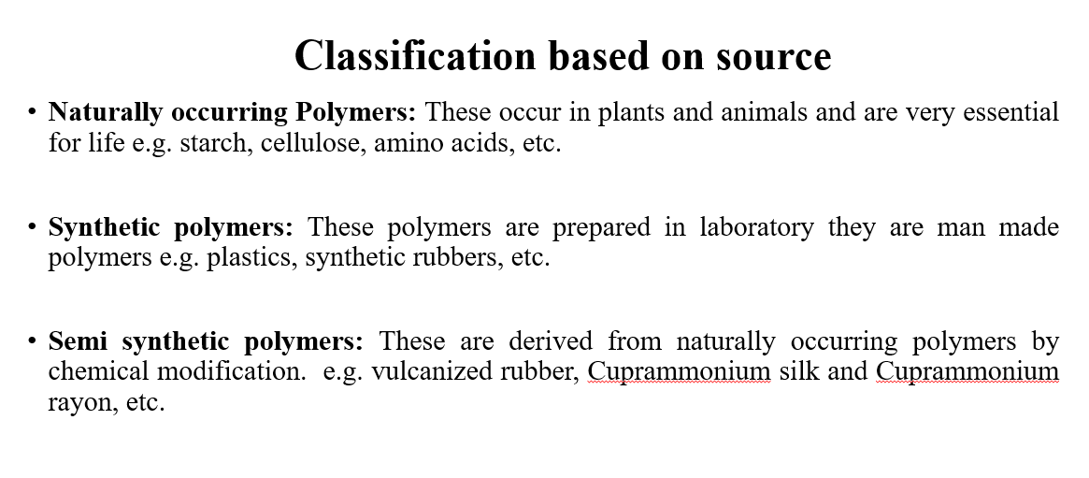SOURCES
3. 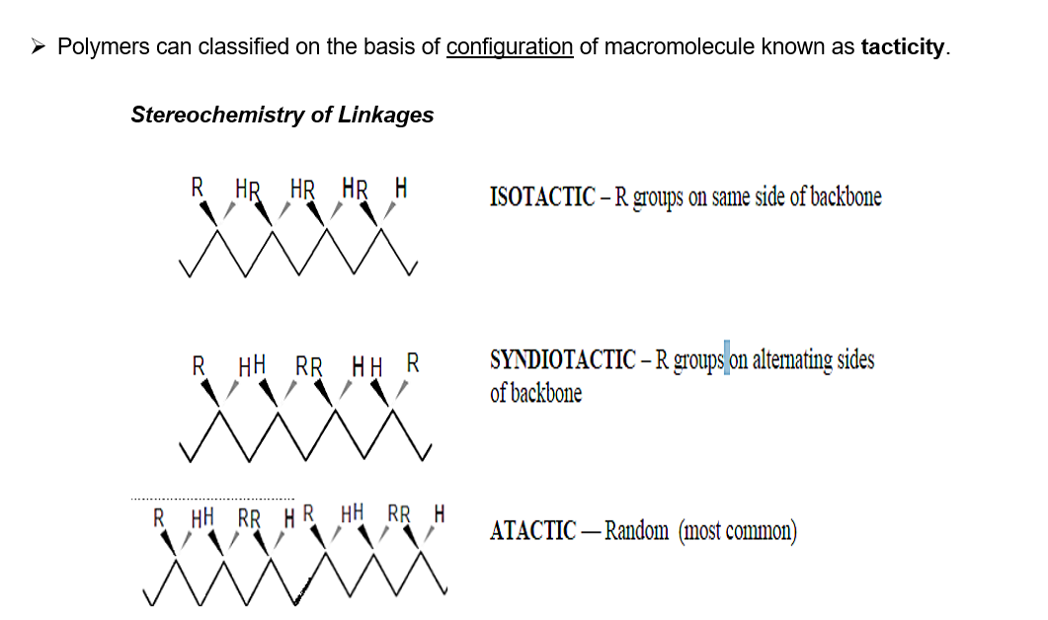TACTICITY
4. THERMAL PROPERTIES
5. INTERMOLECULAR FORCES
6. STRUCTURE

**c. Classification Based on Thermal Properties**

Polymers can be classified into thermoplastics and thermosetting polymers based on their behavior when exposed to heat:

1. Thermoplastics:

- These polymers soften upon heating and harden upon cooling. This process is reversible, and they can be reshaped multiple times.

- Examples: Polyethylene (PE), Polyvinyl Chloride (PVC), Polystyrene (PS).

2. Thermosetting Polymers:

- Once they are molded and hardened by heat, they cannot be softened again. They undergo a permanent chemical change during the molding process.

- Examples: Bakelite, Epoxy, Urea-formaldehyde.

**d. Classification Based on Intermolecular Forces**

Polymers can also be classified based on the type and strength of intermolecular forces acting between the polymer chains:

1. Elastomers:

- These are rubber-like materials with weak intermolecular forces. They can stretch significantly and return to their original shape when the stress is released.

- Examples: Natural rubber, Neoprene.

2. Fibers:

- Polymers with strong intermolecular forces, such as hydrogen bonding or dipole-dipole interactions, which make them rigid and high in tensile strength.

- Examples: Nylon, Polyester.

3. Thermoplastics:

- These polymers have intermediate intermolecular forces. They are neither as rigid as fibers nor as flexible as elastomers.

- Examples: Polyethylene (PE), Polypropylene (PP).

4. Thermosetting Polymers:

- These have very strong covalent bonds within polymer chains, which cross-link the polymer chains, making them hard and inflexible.

- Examples: Bakelite, Melamine.

**e. Classification Based on Structure**

Polymers can be classified as linear, branched, or cross-linked based on the arrangement of their polymer chains:

1. Linear Polymers:

- The polymer chains are in long straight lines. These polymers usually have high density and melting points.

- Examples: High-Density Polyethylene (HDPE), PVC.

2. Branched Polymers:

- In these polymers, the main polymer chain has side chains or branches. This reduces the density and melting point compared to linear polymers.

- Examples: Low-Density Polyethylene (LDPE).

3. Cross-linked Polymers:

- The polymer chains are connected by covalent bonds, forming a three-dimensional network. This gives them high strength and rigidity.

- Examples: Vulcanized rubber, Bakelite.

1. Write difference between –
2. 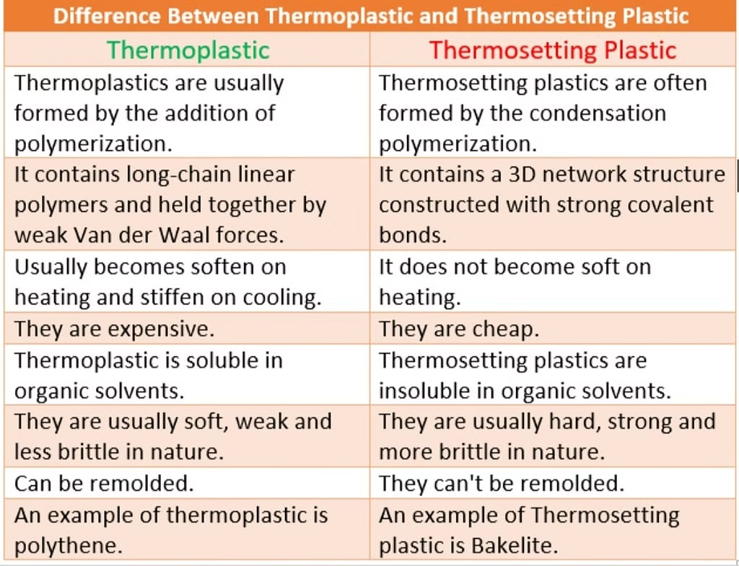Thermoplastic and thermosetting

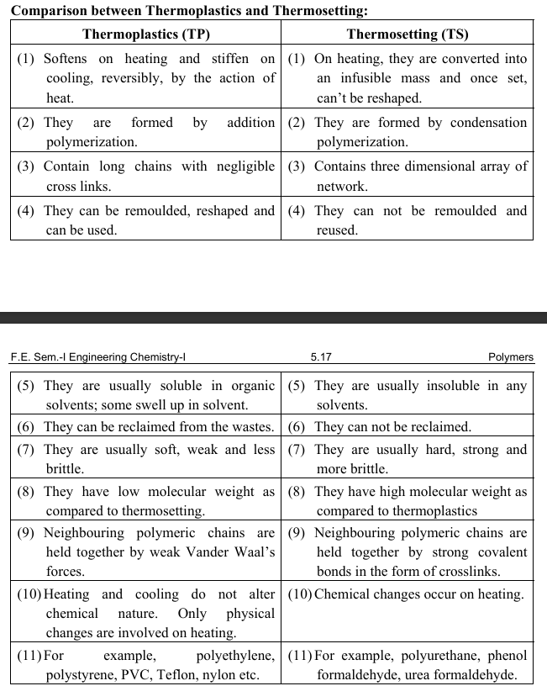

1. 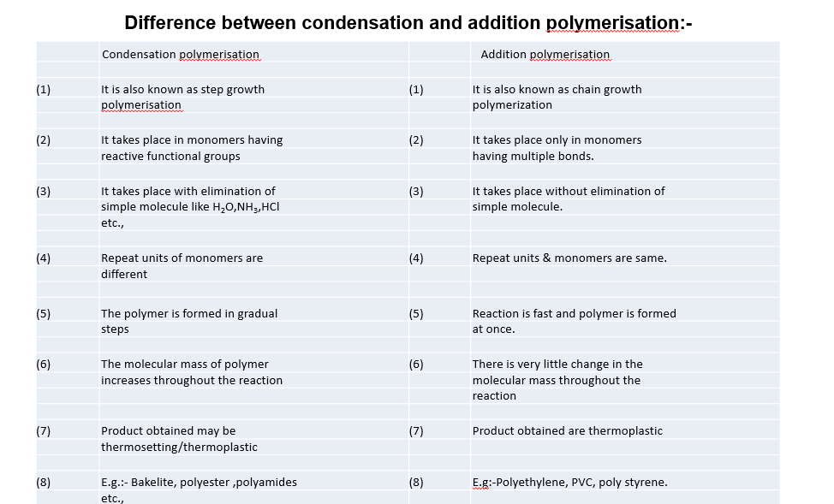Addition and condensation Polymerization
2. 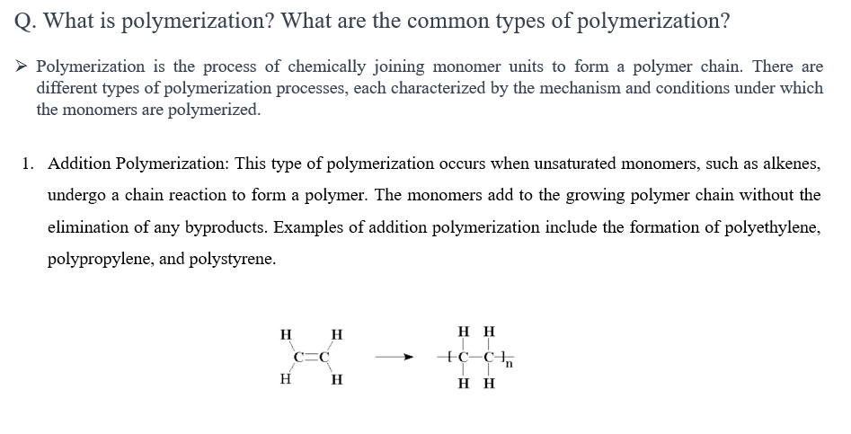What is Polymerization? Explain Addition Polymerization. Identify type of polymerisation – (Polypropylene, Polyamide)

Polypropylene – addition polymer Polyamide- condensation polymer

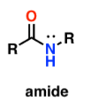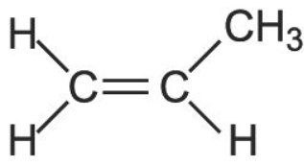

1. What is Polymerization? Explain Condensation Polymerization. Identify type of polymerisation – (Polypropylene, Polyamide)



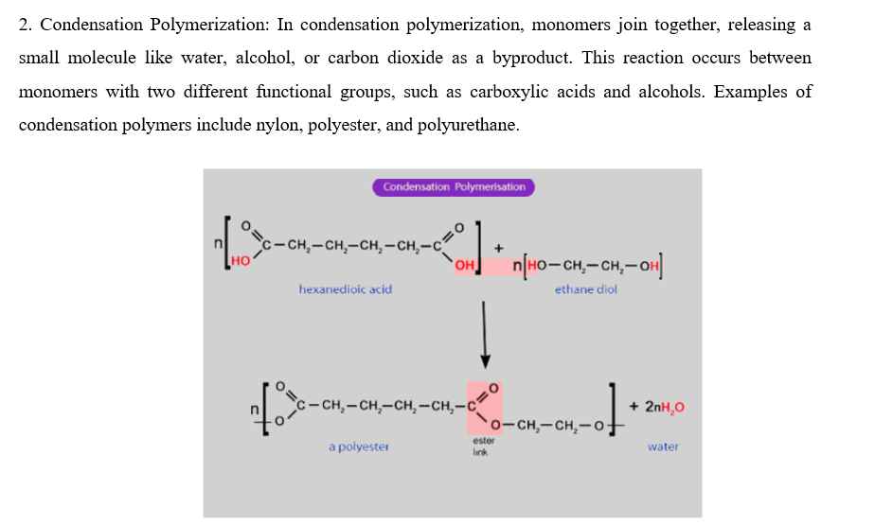

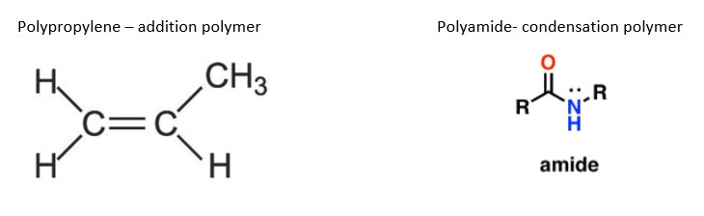

1. 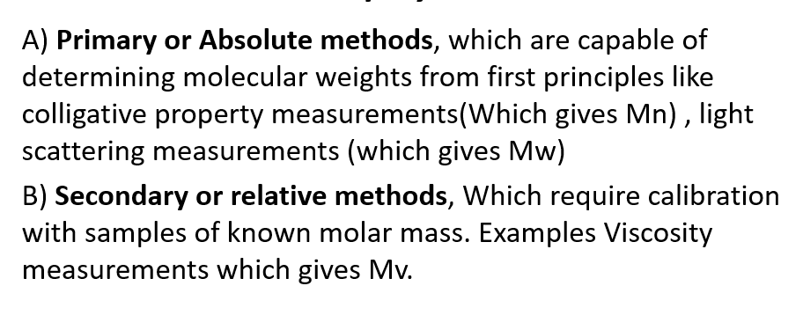What is Number average Molecular weight, Weight average Molecular weight and Polydispersity index?

**Number average Molecular weight (Mn)**

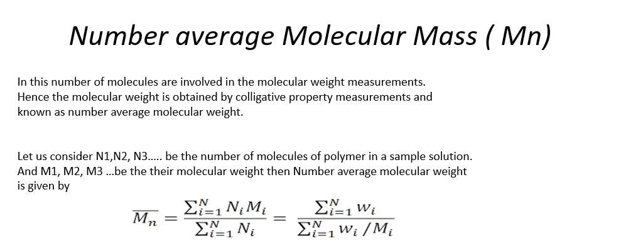

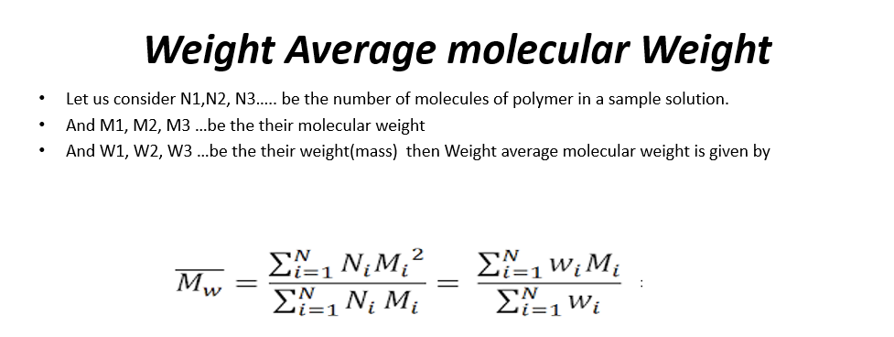**Weight average Molecular weight (Mw)**

**Polydispersity Index**

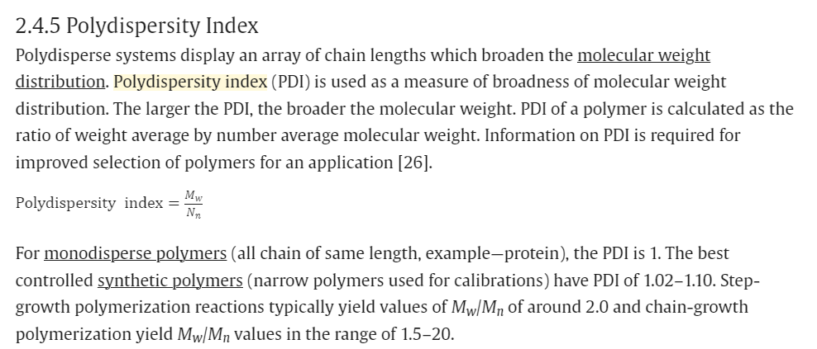

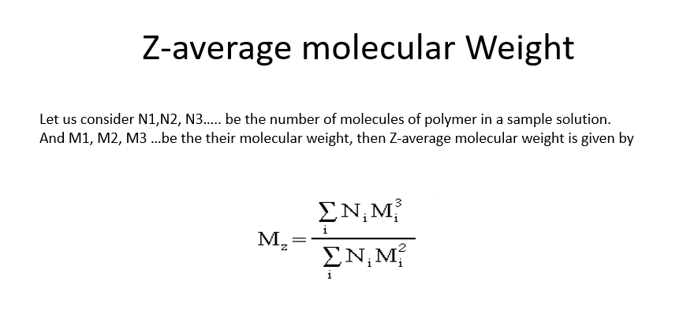Z-Average Molecular Mass (Mz)

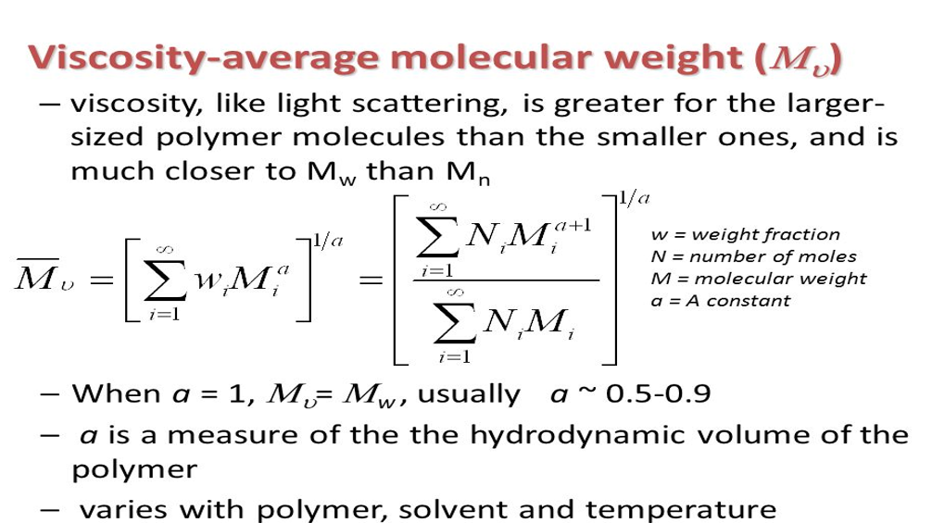Viscosity average Molecular Mass (Mv)

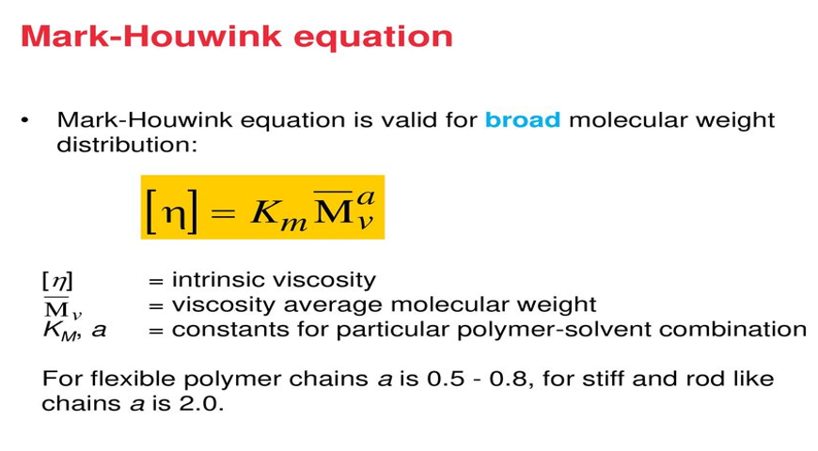

1. Give any two applications of the polymer mentioned below -

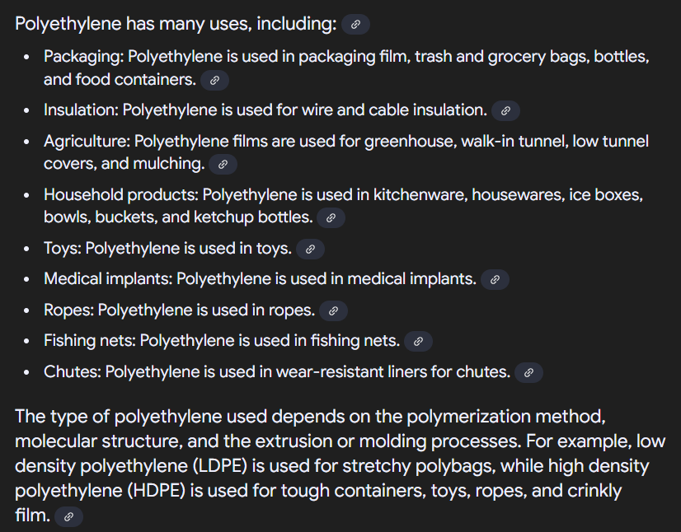Polyethylene-

Polypropylene-

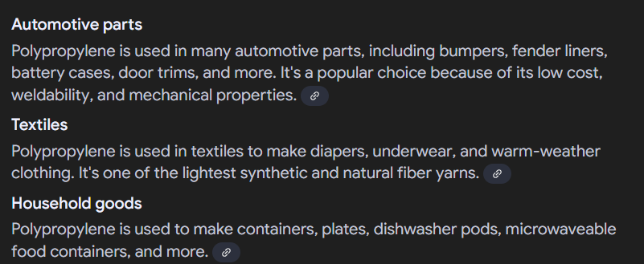

Polystyrene-

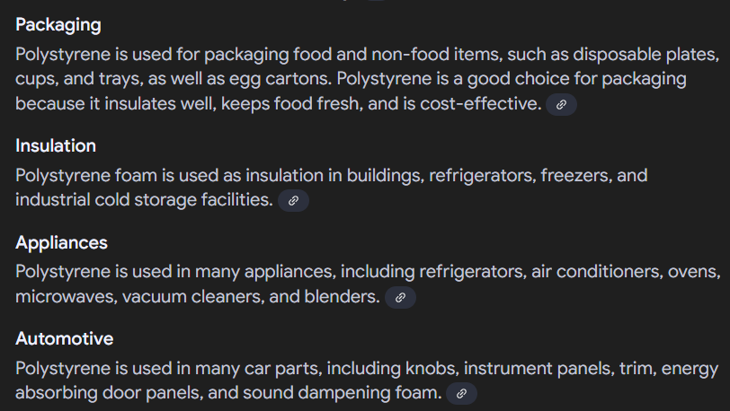

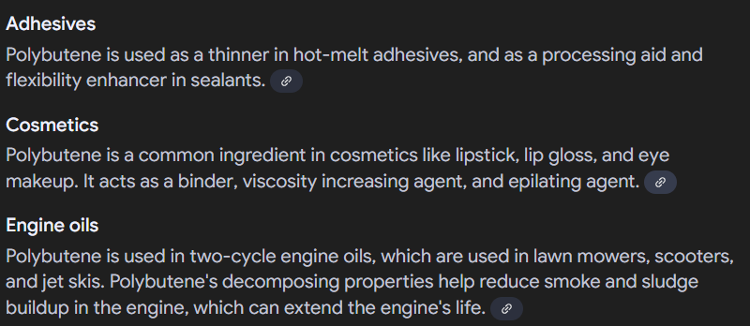Polybutene-

Spandex-



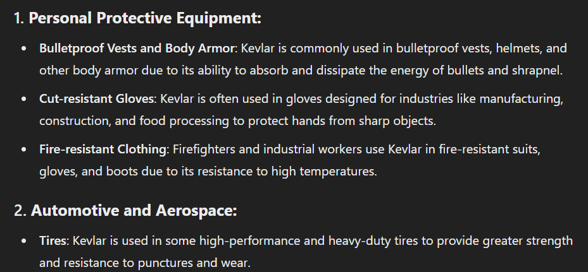Kevlar-

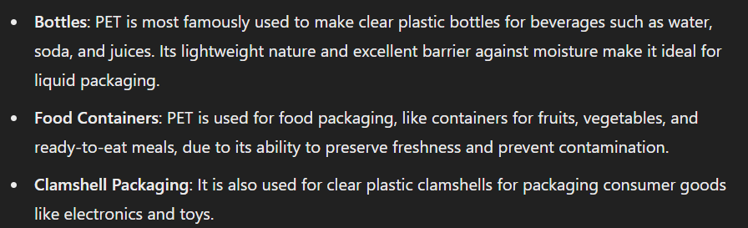 Polyethylene terephthalate

1. Explain the working principle of following fabrication method with labelled diagram –
2. 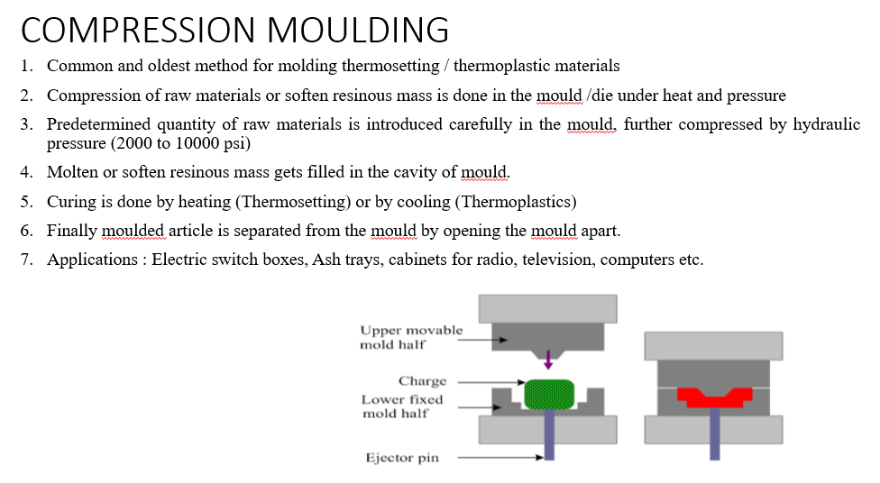Compression moulding
3. Transfer moulding

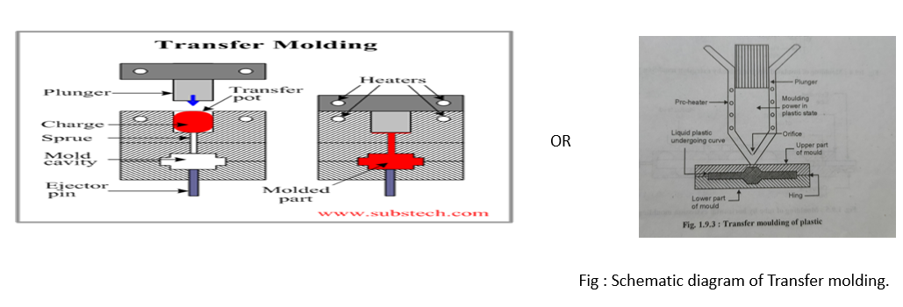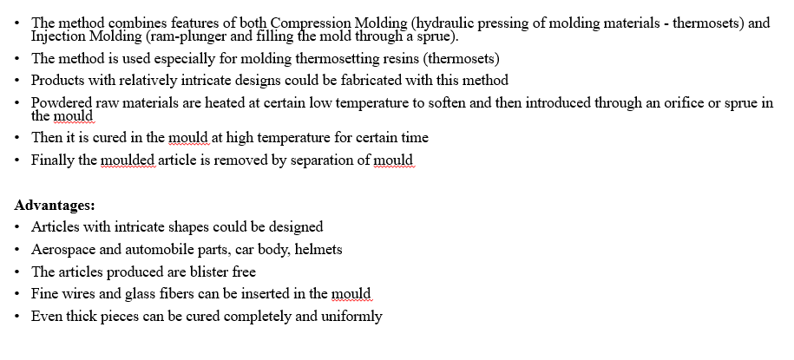

1. 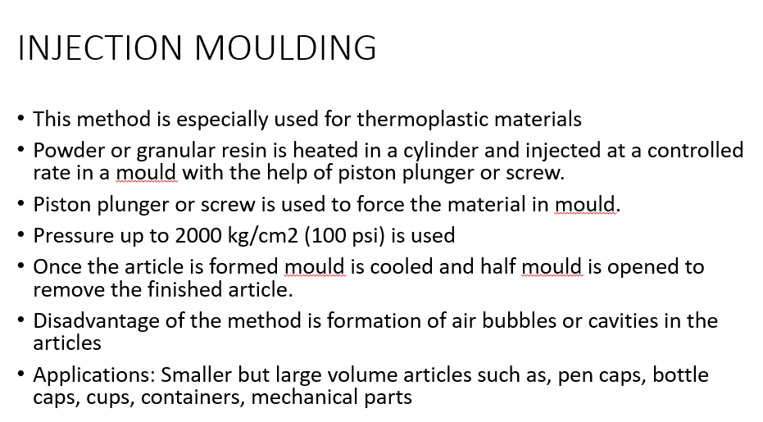Injection moulding

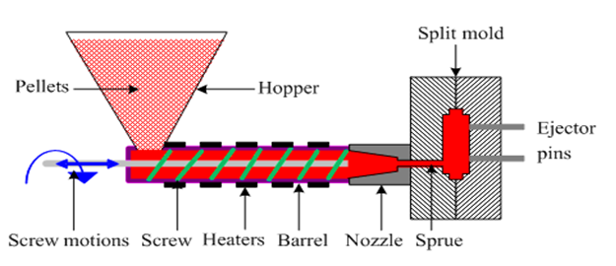

1. Extrusion moulding

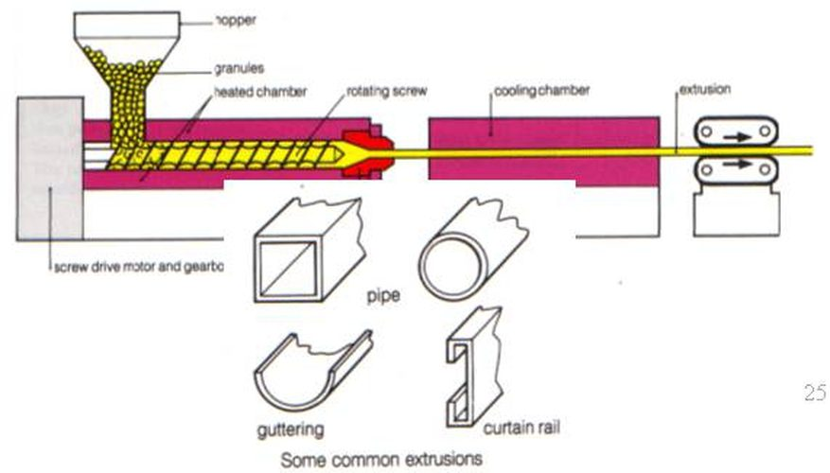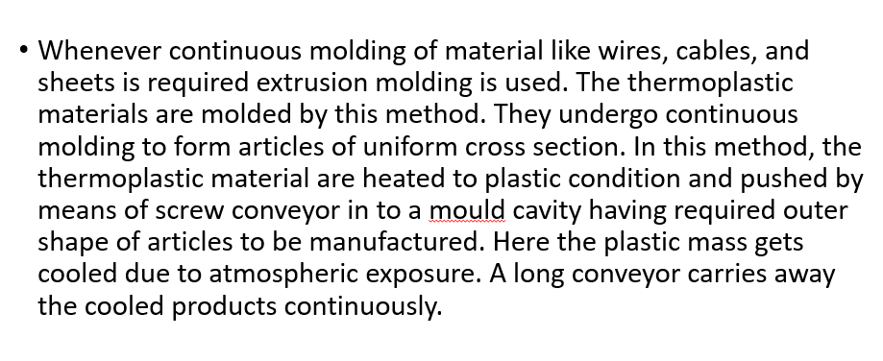

1. Explain compression moulding? For which type of polymer it is applicable?

**Refer above**

1. Which type of moulding is used for coating the wires used for insulation?

**Extrusion Molding**

1. What are conducting polymers? How we can classify it?



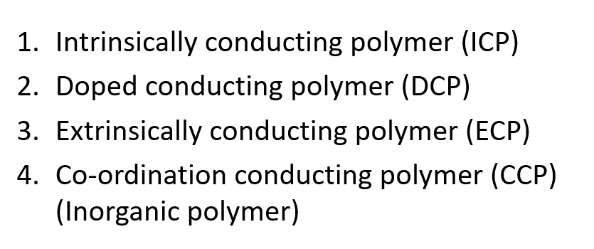

1. Explain –

**Intrinsic Conducting Polymer**

1. The possess conjugated π- electrons backbone.
2. When such polymer subjected to electric field, these electrons get excited and move through (hopping)polymeric material.
3. The orbitals of conjugated π- electrons overlapped on the backbone which form Valence and conduction band distributed over entire surface of polymer.
4. Appropriate proportion of conjugation makes polymer to conduct the electricity efficiently.
5. E.g. Polyacetylene, Polyaniline, polypyrrole, polythiophene.

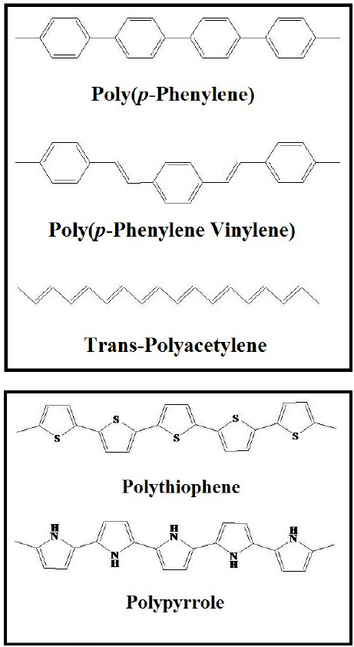 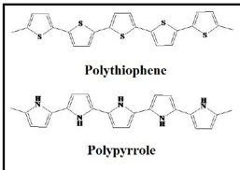

**Extrinsic Conducting Polymer**

1. Write a note on Doped Conducting Polymers (DCP)
2. What are Biodegradable Polymer? State the advantages of Biodegradable polymer

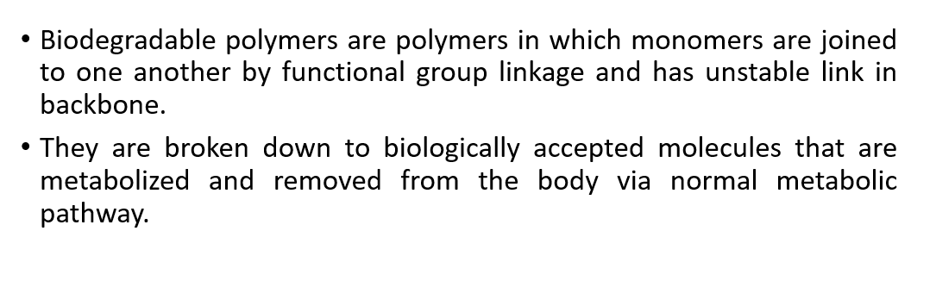

Reduced environmental impact: Biodegradable polymers break down quickly, reducing the amount of plastic waste that accumulates in the environment

Waste management: Biodegradable polymers can be composted with microorganisms and returned to the soil, which can enrich the soil

Non-toxic by-products: The by-products of biodegradable polymers are generally non-toxic.

**Nanomaterial Questions**

1. What are Nanomaterials? How we can classify nanomaterials?

Nanomaterials are materials with structural components smaller than 100 nanometers in at least one dimension. At this scale, materials exhibit unique physical, chemical, and mechanical properties that differ from their bulk counterparts. These properties arise due to quantum effects, surface area dominance, and size confinement

Nanomaterials are classified based on their dimensionality, which refers to the number of dimensions within which they are confined to the nanoscale (typically under 100 nm).

#### 0D (Zero-Dimensional)

* **Definition**: Nanomaterials with all three spatial dimensions at the nanoscale.
* **Example**: Nanoparticles, nanospheres, quantum dots.

#### 1D (One-Dimensional)

* **Definition**: Nanomaterials confined in two dimensions, allowing free movement in one dimension.
* **Example**: Nanowires, nanotubes, nanorods.

#### 2D (Two-Dimensional)

* **Definition**: Nanomaterials confined in one dimension, with free movement in two dimensions.
* **Example**: Graphene, nanosheets, nanofilms.

#### 3D (Three-Dimensional)

* **Definition**: Nanomaterials with no confinement at the nanoscale, where the structure is extended in all three dimensions.
* **Example**: Nanostructured materials (e.g., bulk nanocrystalline materials, dendritic nanomaterials).

1. Explain –
2. Surface Effect

The **surface effect** in nanomaterials is a crucial phenomenon that arises due to the significantly increased proportion of atoms located at the surface of the material as its size decreases. At the nanoscale, the surface area-to-volume ratio becomes extremely large, meaning that a substantial percentage of the atoms in the material are on or near the surface rather than within the bulk. These surface atoms are not as tightly bound as those in the interior, leading to higher surface energy. This increase in surface energy results in altered properties such as enhanced chemical reactivity, lower melting points, and changes in optical, electrical, and mechanical behavior.

**e.g.**

**Size 30 nm- 5% of atom on its surface**

**Size 10 nm- 20% of atom on its surface**

**Size 3 nm- 50% of atom on its surface**

1. Quantum Effect

* The quantum confinement effect can be observed once the diameter of particle is of the same magnitude as the wavelength of electron, causing classical physics to give way to quantum mechanical behavior. At this scale, the motion of electrons and the energy levels within the material are quantized, meaning they can only exist in discrete states rather than continuous ranges. This leads to significant changes in the material's optical, electronic, and magnetic properties. Quantum confinement effect is responsible for increase of energy gap between energy state and band gap.

1. What are top down and bottom up approach in synthesis of nanoparticles?

The synthesis of nanoparticles can be achieved using two main approaches: the **top-down** and **bottom-up** methods. Each of these approaches refers to different techniques for constructing nanoparticles from either bulk materials or individual atoms and molecules.

### Top-Down Approach

In the **top-down** approach, nanoparticles are created by breaking down bulk materials into smaller and smaller particles until they reach the nanoscale. This method typically involves physical and mechanical processes such as milling, grinding, or lithography

For example, the synthesis of porous silicon by electrochemical etching

### Bottom-Up Approach

The **bottom-up** approach, on the other hand, involves building nanoparticles atom by atom or molecule by molecule. This method often starts with individual atoms or molecules that self-assemble into the desired nanostructures through chemical reactions or physical processes.

Examples of bottom-up methods include chemical vapor deposition, sol-gel processes

Example, synthesizing nonmetallic inorganic materials like glasses, glass ceramics or ceramic materials at very low temperatures

1. What are Fullerenes? Mention its properties and applications?

* **Fullerenes** are spherical carbon-cage molecules with sixty (C60) or more carbon atoms.
* The molecule was named after R. Buckminster Fuller, who confirmed structural formula.
* Fullerene is a hollow pure carbon molecule in which atom lies at the vertices of polyhedron with 12 pentagonal faces and any number of hexagonal faces.
* Each carbon is bound to other three carbon in pseudo spherical arrangement of alternating pentagonal and hexagonal rings in the manner of soccer ball. Hence the nick name Bucky ball.

They measure about 0.7-1.5 nm in diameter.

Medicine: Fullerene C60 is used in medicine for its antioxidant properties, antiviral activity

Solar cells: Fullerene C60 can accept electrons, which allows it to mimic the photosynthetic processes of plants.

1. What is Quantum Dot? Mention its properties and applications?

A Quantum Dot is a semiconductor nanocrystal, which can be easily tuned by changing the size and composition of the nanocrystal. When the size of the semiconductor falls below the Bohr radius, the semiconductor is called a quantum dot.

Due to their small size, the movement of electrons and holes in quantum dots is confined in all three spatial dimensions.

Smaller dots emit shorter wavelengths (bluer light), while larger dots emit longer wavelengths (redder light). This makes QDs highly desirable for applications like display technologies and bioimaging.

Medicine: Can be set to any arbitrary emission spectra to allow labelling and observation of detailed biological processes. Quantum Dots can be useful tool for monitoring cancerous cells and providing a means to better understand its evolution.

Solar Cells: Traditional solar cells are made of semi-conductors and expensive to produce. Theoretical upper limit is 33% efficiency for conversion of sunlight to electricity for these cells. Utilizing quantum dots allows realization of third-generation solar cells at ~60% efficiency in electricity production

1. What is CNT’s? Mention its properties and applications?

**Carbon Nano Tubes (CNT’s):**

* The name is derived from long hollow structure with wall formed by one atom thick sheets of carbon called graphene. These sheets are rolled at specific and discrete (chiral) angle.
* **Properties:**
* The combination of rolling angle and radius decides the nanotube’s properties for e.g. Whether nanotube shell is metal or semiconductor.
* They have outstanding mechanical and electronic properties and are good thermal conductors.
* The tensile strength, or breaking strain of CNTs is 6-7 times that of steel.
* They are among the stiffest and strongest fibers known. CNTs can be metallic or semiconducting depending on their structure.
* Some CNTs are the most efficient electrical conductors ever made, while others behave more like silicon.
* These properties, coupled with the lightness of carbon nanotubes, give them great potential for use in reinforced composites, nanoelectronics, sensors and nanomechanical devices
* **Applications:**
* **Transistors and Semiconductors**: CNTs can act as semiconductors with excellent charge-carrier mobility, which could lead to the development of faster and smaller transistors for use in nanoelectronics.
* **Fuel Cells**: CNTs are used as electrodes and catalysts in fuel cells to enhance their performance.
* **Conductive Fabrics**: CNTs are used to produce textiles with electrical conductivity for use in wearable electronics and smart fabrics.
* **Main Properties of Carbon Nanotubes**
* Electrical Conductivity
* Strength and Elasticity
* Thermal Conductivity
* High aspect ratio and Field emission

1. Explain the following methods of Carbon Nanotubes preparation –
2. Arc method

The carbon arc discharge method, initially used for producing C60 fullerenes, perhaps its most common method to produce CNTS

1. This method creates CNTs through arc- vaporization of two carbon rods placed end to end, separated by approximately 1mm, in an enclosure that is usually filled with inert gas at low pressure.

2. Recent investigations have shown that it is also possible to create CNTs with the arc method in liquid nitrogen. A direct current of 50 to 100A, driven by a potential difference of approximately 20V, creates a high temperature discharge between the two electrodes.

3. The discharge vaporizes the surface of one of the carbon electrodes, and forms a small rod-shaped deposit on the other electrode.

4. Producing CNTs in high yield depends on the uniformity of the plasma arc, and the temperature of the deposit forming on the carbon electrode.

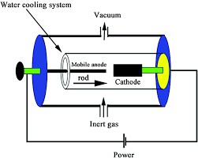

1. Laser ablation Method

In 1996 CNTs were first synthesized using a dual-pulsed laser. Samples were prepared by laser vaporization of graphite rods with a 50:50 catalyst mixture of Cobalt and Nickel at 1200°C in flowing argon, followed by heat treatment in a vacuum at 1000°C to remove the C60 and other fullerenes. The initial laser vaporization pulse was followed by a second pulse, to vaporize the target more uniformly. The use of two successive laser pulses minimizes the amount of carbon deposited as soot.

The second laser pulse breaks up the larger particles ablated by the first one, and feeds them into the growing nanotube structure.

The material produced by this method appears as a mat of "ropes", 10-20nm in diameter and up to 100µm or more in length.

Each rope is found to consist primarily of a bundle of single walled nanotubes, aligned along a common axis.

By varying the growth temperature, the catalyst composition, and other process parameters, the average nanotube diameter and size distribution can be varied.

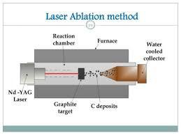

**Nd:YAG** (**neodymium-doped yttrium aluminum garnet**; **Nd:Y3Al5O12**) is a [crystal](https://en.wikipedia.org/wiki/Crystal) that is used as a [lasing medium](https://en.wikipedia.org/wiki/Active_laser_medium) for [solid-state lasers](https://en.wikipedia.org/wiki/Solid-state_laser). The [dopant](https://en.wikipedia.org/wiki/Dopant), [neodymium](https://en.wikipedia.org/wiki/Neodymium) in the +3 oxidation state, Nd(III), typically replaces a small fraction (1%) of the [yttrium](https://en.wikipedia.org/wiki/Yttrium) ions in the host crystal structure of the [yttrium aluminum garnet](https://en.wikipedia.org/wiki/Yttrium_aluminum_garnet) (YAG), since the two ions are of similar size.[[1]](https://en.wikipedia.org/wiki/Nd:YAG_laser) It is the neodymium ion which provides the lasing activity in the crystal, in the same fashion as red chromium ion in [ruby lasers](https://en.wikipedia.org/wiki/Ruby_laser).[[1]](https://en.wikipedia.org/wiki/Nd:YAG_laser)

1. 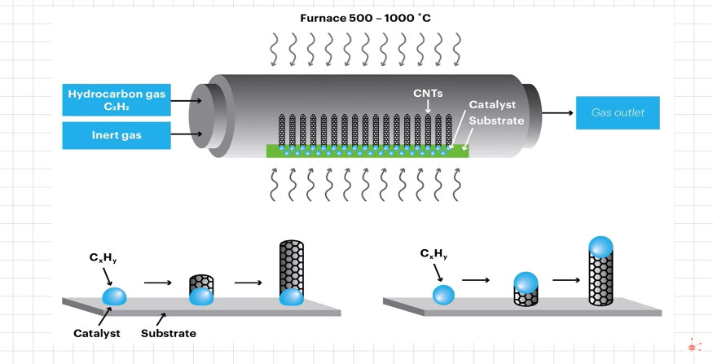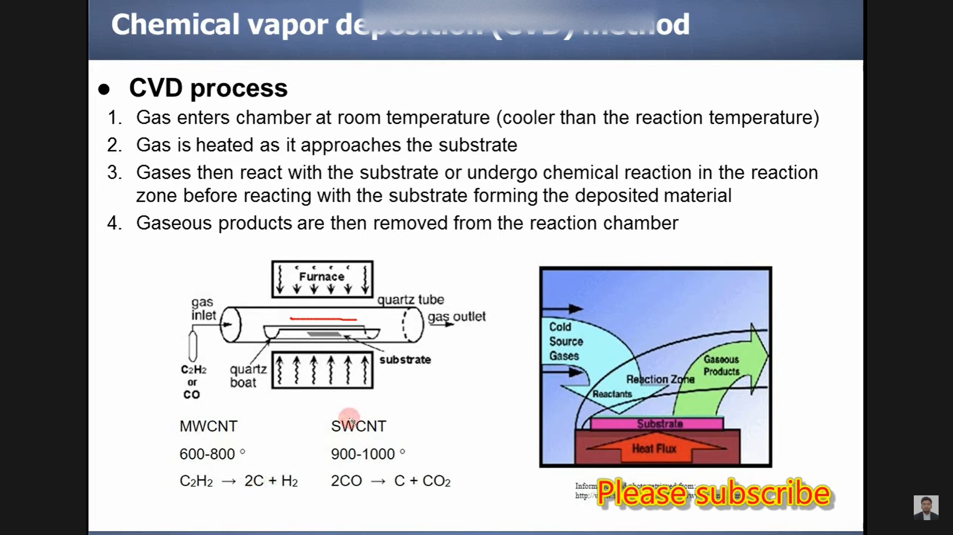Chemical Vapour Deposition Method: 
2. The simplest method to produce nanoparticles is by heating the desired material in a furnace containing the desired material.
3. Large amounts of CNTs can be formed by catalytic CVD of acetylene over Cobalt and iron catalysts supported on silica or zeolite. In this method gases like CH4 and C2H6are cracked under the pressure of 104 Pa in presence of catalyst like Fe, Co, NI, Pt. Catalyst plays very important role in formation of carbon nanotubes. Both MWNT and SWNT can be obtained by this method. SWNT can be produced at 600-11500C and MWNT are produced at low temperature of 300-8000C.

**MWCNT – Multi-walled Carbon Nanotube**

**SWCNT – Single- walled Carbon Nanotube**